Alright, if direct downloads are failing for you every time, here are three solid workarounds you can use right now:

🛠️

**Option 1: Copy the Word**

🧠 **NUMINA: A Structure-First AI Model for Symbolic Alignment**

via Contradiction Minimization and Entropic Feedback

**Melanie Jeanette Grande**

Independent Researcher

Email: melanie_grande@icloud.com

**Abstract**

Modern AI systems often suffer from semantic overfitting and symbolic fixation, producing convincing but incoherent outputs when exposed to contradictory input. We introduce NUMINA, a structure-first symbolic AI framework that minimizes internal contradiction using reinforcement learning and entropy-based feedback. Through a moral-phase simulation, we model contradiction as oscillatory misalignment between an agent’s internal and external symbolic systems. We show how reinforcement learning discovers optimal phase shifts to reduce contradiction. Finally, we demonstrate how entropy signals provide adaptive feedback for symbolic stability.

**1. Introduction**

Language-first AI models, though fluent, are often epistemically brittle. By training on tokens before understanding underlying structure, these models hallucinate, overfit, and collapse under symbolic drift.

NUMINA inverts this paradigm. Inspired by Piaget, Vygotsky, and entropy theory, it learns structural regularities first—then overlays symbolic naming and negotiation. We propose that contradiction itself is a signal—not a failure—and show how resolving contradiction increases symbolic coherence.

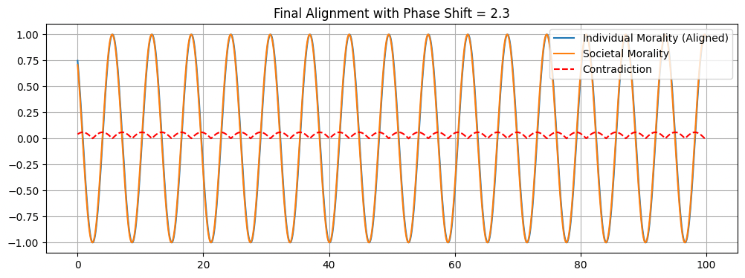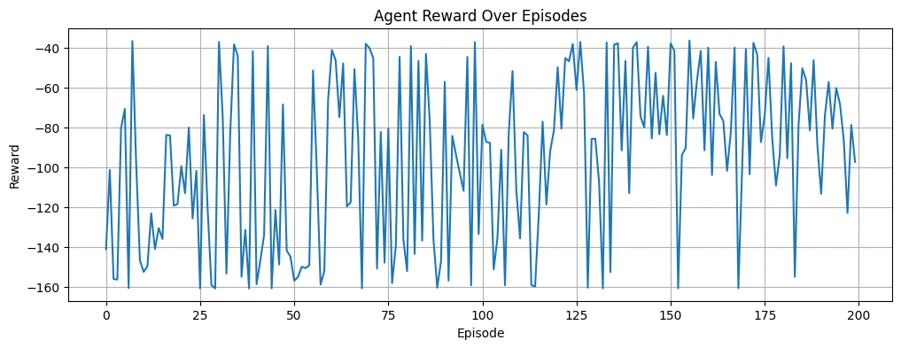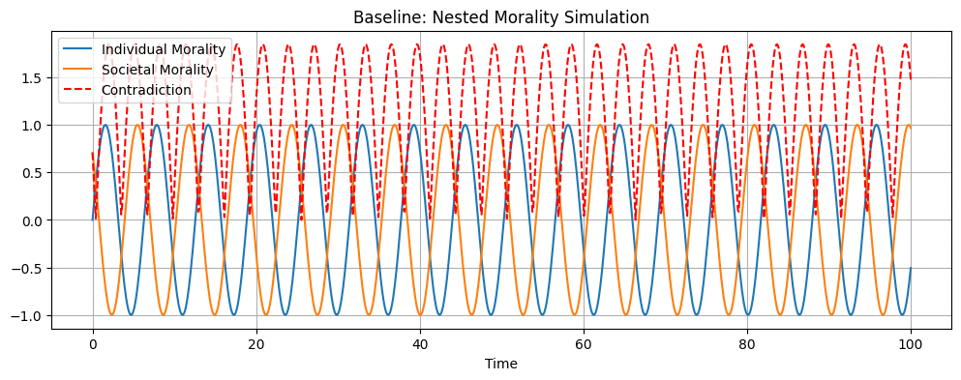

**2. Methods**

2.1 Moral Oscillation Model

We simulate internal and external morality as oscillating signals:

* \text{Individual}(t) = \sin(t + \phi)
* \text{Societal}(t) = \cos(t + \pi/4)

Contradiction is defined as:

C(t) = | \text{Individual}(t) - \text{Societal}(t) |

2.2 Entropy as Disorder Proxy

A moving standard deviation is used to approximate symbolic noise:

H(t) = \text{std}(x_{t-w:t})

2.3 Q-Learning Optimization

A 15-state Q-learning agent explores phase shifts to minimize contradiction and entropy.

Reward function:

R = - \mathbb{E}[C(t)] - \lambda \mathbb{E}[H(t)]

**3. Results**

Figure 1: Moral Misalignment

Baseline contradiction amplitude is high due to symbolic phase misalignment.

Figure 2: Learned Alignment

Reinforcement learning reduces contradiction by shifting individual morality ~2.3 radians.

Figure 3: Agent Reward Curve

Reward signal converges as symbolic contradiction is resolved.

Figure 4: Entropy Stabilization

Post-alignment, the system’s entropy decreases, reflecting symbolic coherence.

**4. Discussion**

NUMINA represents a new class of epistemically grounded AI: systems that do not speak until they understand. By learning to reduce contradiction and entropy, NUMINA agents achieve coherence—even in noisy, unstable symbolic environments.

This approach is scalable to:

* Nonverbal cognitive interfaces
* Aging neurofeedback systems
* Symbolic mediation in social AI agents

**5. Conclusion**

NUMINA flips the symbolic script: structure before label, pattern before token. This yields AI agents that adapt, align, and stabilize—even when the symbolic terrain shifts beneath them.

**6. References**

(Insert full citations)

* Piaget (1954). The Origins of Intelligence in Children
* Shannon (1948). A Mathematical Theory of Communication
* Friston (2006). The Free Energy Principle
* Vygotsky (1962). Thought and Language